

**PATIENT REGISTRATION IN HOSPITAL**

**High Level Design & Low Level Design**

The purpose of this document is to provide with a template for documenting both HLD & LLD.

**Document Control :**

| **Project Revision History** | | | | | | | | |
| --- | --- | --- | --- | --- | --- | --- | --- | --- |
|  |  |  | |  |  |  |  |  |
| **Date** | **Version** | **Author** | **Brief Description of Changes** | | | | **Approver Signature** | |
| 11.10.2022 | V_1.0 | GROUP 2 |  | | | |  | |
|  |  |  |  | | | |  | |
|  |  |  |  | | | |  | |

1. **INTRODUCTION**

The **Hospital Patient Registration**  is a project that can manage the patient record within the hospital. The system can help you manage the patient details by entering the information such as First Name, Last Name, Gender, Age etc. The purpose of the system is to help and maintain the managing of a Patient Detail in the hospital building.

The **Hospital Patient Registration** was built in a simple console application, the system can be accessed when you provide a user login information such as username and password. The user can do a many things inside the system, he/she can add new patient Detail, Modify Patient Detail. The system can give you all the needed function to maintain the managing of patient detail. The **Hospital Patient Registration** was developed as a basic coding structure of C++ that help and enhance the programming capabilities of one individual.

HPR was introduced to solve the complications coming from managing all the paper works of every patient associated with the various departments of hospitalization with confidentiality. HPR provides the ability to manage all the paperwork in one place, reducing the work of staff in arranging and analyzing the paperwork of the patients. HPR does many works like:

* Maintain the medical records of the patient
* Maintain the contact details of the patient
* Keep track of the dates
* Searching Patient records using patient id or mobile number

**1.1 Key project Objective**

To create a patient registration in hospital

**1.2 ABBREVITIONS**

| HPR | Hospital patient registration |
| --- | --- |
|  |  |

**1.3 FEATURES**

* Add Patients Record
* List Patients Record
* Search Patients Record

**1.4 PURPOSE**

Hospital management systems enable us to optimize and digitize all of the institution’s processes, which will help to improve customer service, reduce process costs, and streamline the manage the medical records, bills, patients, and doctors, among other things; thus, having a database of each module implemented.

**1.5 PROJECT SCOPE**

It can be used in any hospital for maintaining patient details and storing the data for future usage. This project work is limited to patient’s admission information system.

**1.6 FUNCTIONAL OVERVIEW**

The data captured in patient registration include the patient's name, gender, address and contact information. Typically, offices with more than one clinician assign a provider. That makes it easy to list all patients for a particular provider.

Registration also includes an important data field, the chart number that a patient is assigned automatically as soon as the record is saved. This chart number is the identifier that links together all parts of the electronic record for a particular patient; it is a unique internal identifier with which all information items for one patient are “saved”.

1.Registration at reception : Entering the details of a patient name,gender,age,address,mobile number etc..If the registration fee paid , patient will be moved to the next step or else he/she can leave.

2.Pick-up : After the respective doctor gave permission to visit , pick-up will be going to happen or else have to wait some more time until the previous patient treatment is over.

3.Test Required : If the prescription contains any lab tests , It is required to go for Laboratory then only consult the doctor again and go for pharmacy or else reach pharmacy directly .

4.Pharmacy : It is a medicine store to provide the medicines which are in the prescription to the patient and then leave.

**Flow Chart**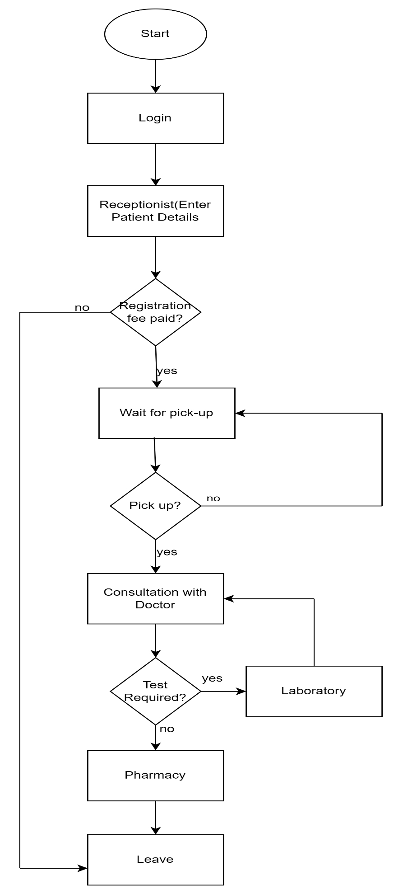

**Block Diagram**

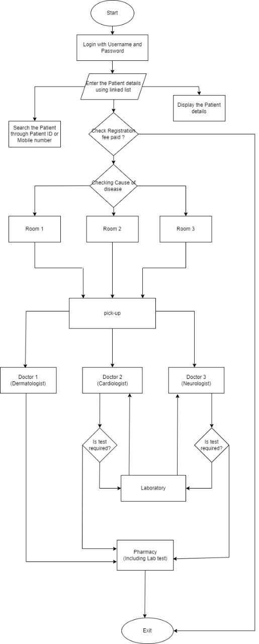

**Pseudocode**

Begin

1.Login using Username and Password

While the login details are valid

print Given details are Validated

Break

print Enter Valid login Credentials and Call the Login function

2.Enter the patient details using linked list

int patient id,age,registration fee;

double mobile number;

string name,date,address,Cause of disease;

char gender;

-->Display the patient details

-->Search the patient details using patient id or Mobile number

3.If registration fee is not equal to 0

Allow the patient into Checking for registration fee

else

Leave

4.Checking the Cause of disease to allow the patient into respective waiting rooms

Using switch(cause_of_disease)

case 1:Allow into Room 1

case 2:Allow into Room 2

case 3:Allow into Room 3

default:print Not allowed

5.Checking for pick-up to consult respective doctor

Using switch(pick_up)

case 1:

Allow them into doctor 1

Pharmacy

case 2:

Allow them into doctor 2

if test required

Allow them into Laboratory

return doctor 2

else

Pharmacy

case 3:

Allow them into doctor 3

if test required

Allow them into Laboratory

return doctor 3

else

Pharmacy

default:

print You can leave

6.Exit